An Approach to Sustain Healthcare Reform Efforts: The SIM Transition Team
Maine’s State Innovation Model (SIM) Test is generating momentum among providers, payers, and consumers to achieve the Triple Aim goals for healthcare. Key to Maine sustaining this momentum after the test period will be the leadership and organization of a team to continue and transition the successful SIM healthcare reform strategies and activities. The SIM Transition Team will focus on the innovations developed under SIM for MaineCare, but may also include healthcare transformation activities that require convening of health care payors and other stakeholders to sustain reform activity and implement multi-stakeholder sustainability strategies determined effective based on learning from the SIM evaluation and additional perspective provided through stakeholders as convened through SIM governance.
A draft of the accountabilities of the SIM Transition team are as follows:
- Manage mainstreaming of sustained SIM capabilities
- SIM evaluation results wrap up and final recommendation development, management, and dissemination
- Facilitate the development of and manage strategies/policies to pursue as a result of SIM learning
- Ongoing convening of Governance structure as needed to provide expertise and input to those strategies identified in #3
- Managing any SIM adjustments that create ongoing SIM funded activity beyond 9/30/16
- Continued execution of reporting to CMMI, as required
- RFP development for the future needs of SIM sustainability and transition related work for DHHS
- Contract development for the future needs of SIM and transition related work for DHHS
- Budgetary oversight of funding for continued and newly developed programs
- Work process development integrating new policies and programs into MaineCare and CDC

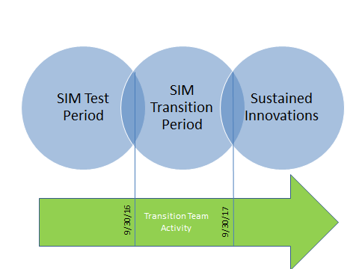
Funding
- The SIM Transition Team funding would be covered from remaining SIM funds available as a result of Maine’s No-cost extension request and subsequent approval to 9/30/17.
- The money is available from SIMs contingency funds that were never allocated
- Estimated cost of SIM Transition Team is $450,000 for one year of transition related work

